## **Deliverable 2 Report - Gun Violence - Team 5**

### **Datasets used:**

1. City_Council_Districts_-_Effective_for_the_2023_Municipal_Election.shp
2. Police_Districts/Police_Districts.shp
3. Crime_reports 2015 - 2023
4. Boston Shootings file

### **Questions Asked:**

1. What is the rate of gun violence in District 4? How does this compare to the rest of the city?
2. Are there patterns of violence in terms of location in District 4? How does this compare to the rest of the city?

### **Early Insights:**

#### Deliverable 1

1. Matching police district and city council districts
2. Preliminary analysis of gun violence statistics in district 4 and the whole Boston area
3. Preliminary analysis of crime violence statistics in district 4 and the whole Boston area

#### Deliverable 2

1. Further analysis of gun violence patterns specifically in District 4
2. Further analysis of gun violence patterns in the whole Boston area

### **Observations:**

**First Insight**

#### First, we had an analysis of Boston city council districts and police districts and matched them with shooting crime locations:

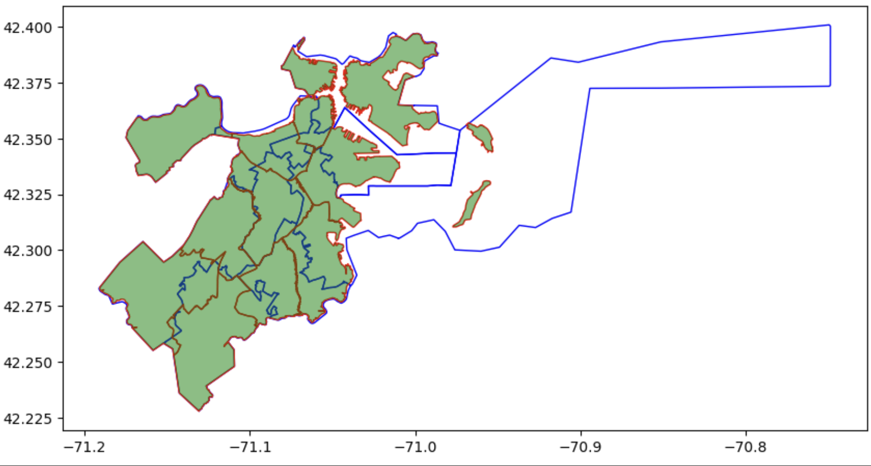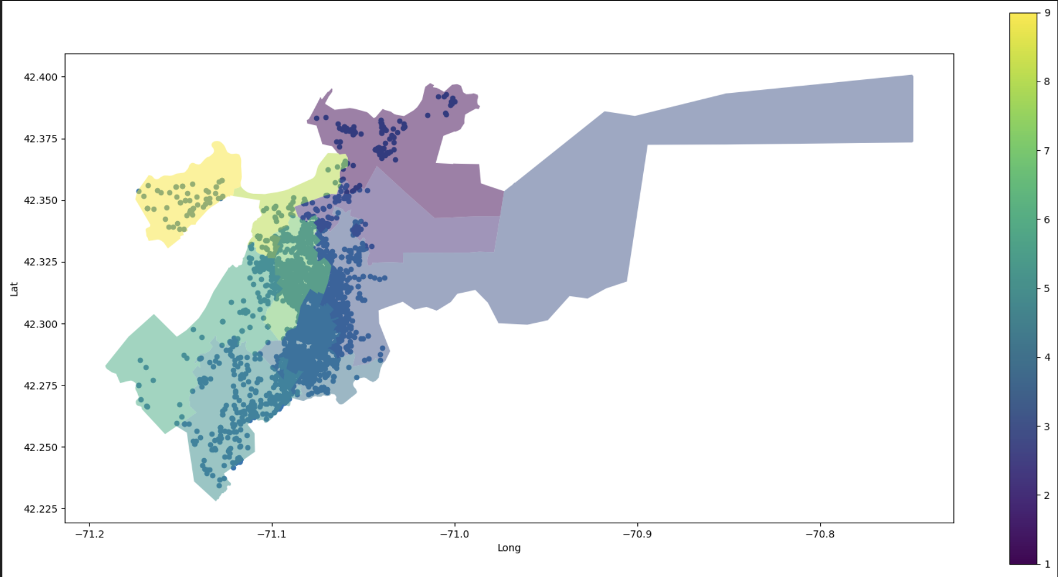

Matching police districts and council districts Matching shooting crimes with city council districts

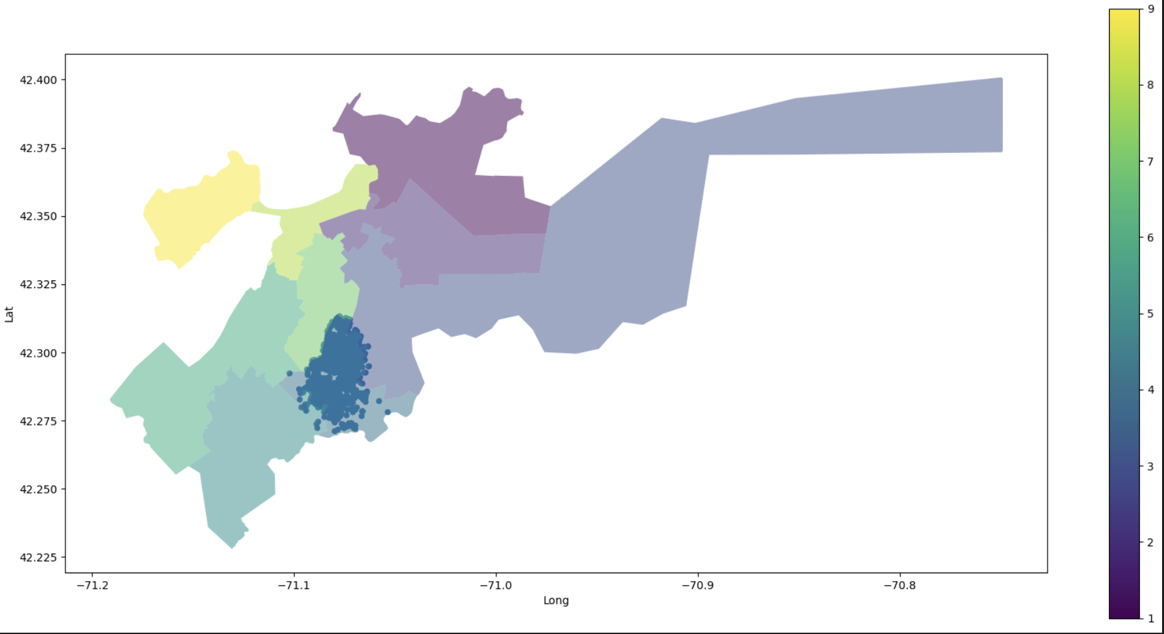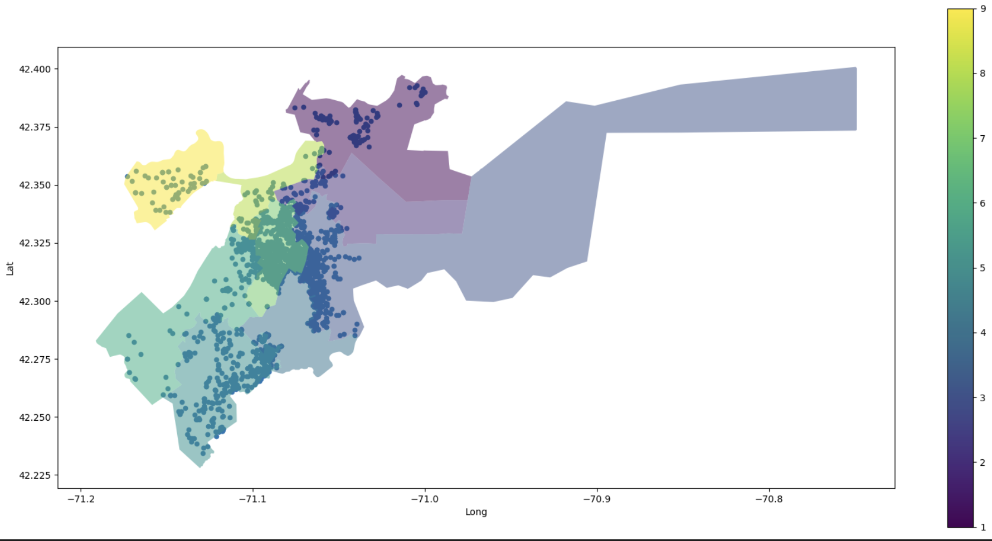

Separating shooting events in District 4 and the rest of the city

After separating shooting events in district 4, we figured out they majorly occurred in police districts B2, B3, and C11. Given that, we had preliminary evaluations of the proportion of the number of incidents that happened in those areas and the rest of the city,

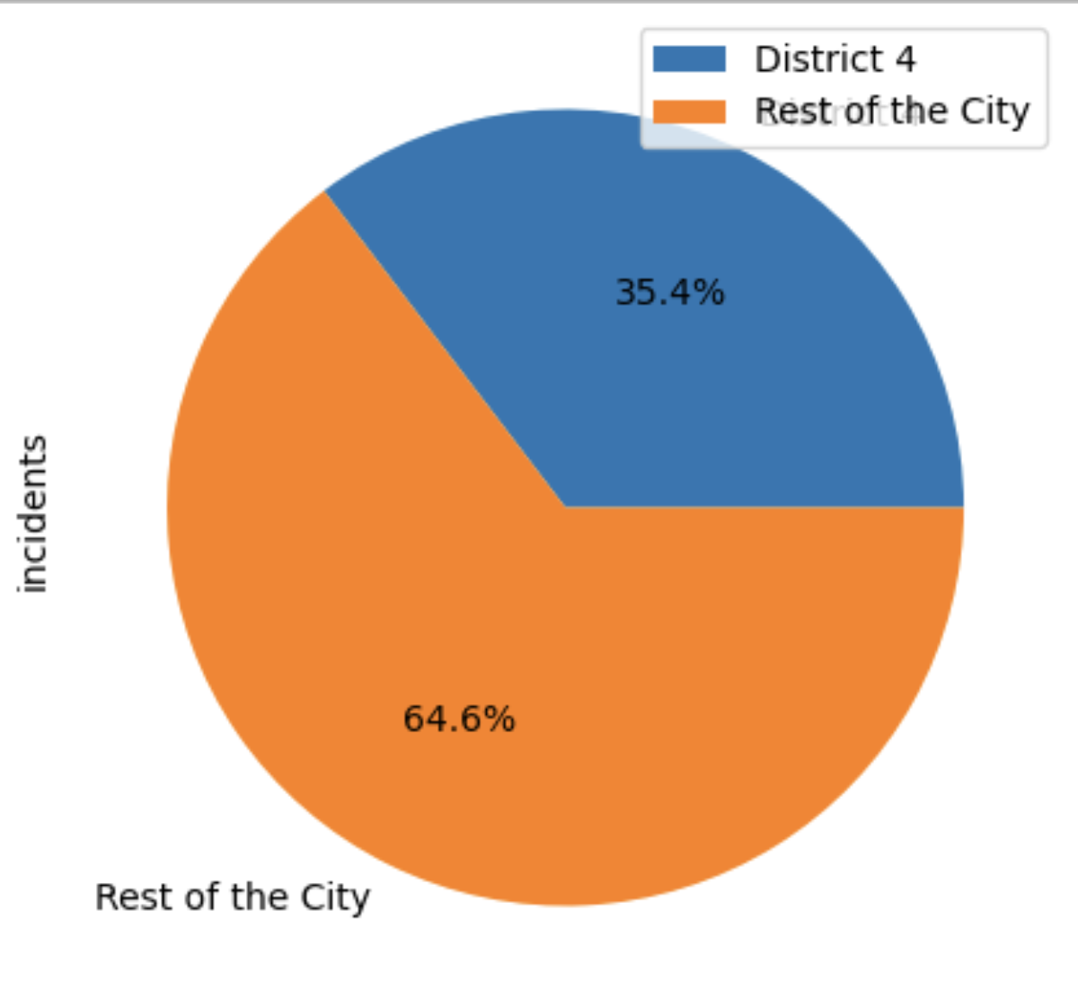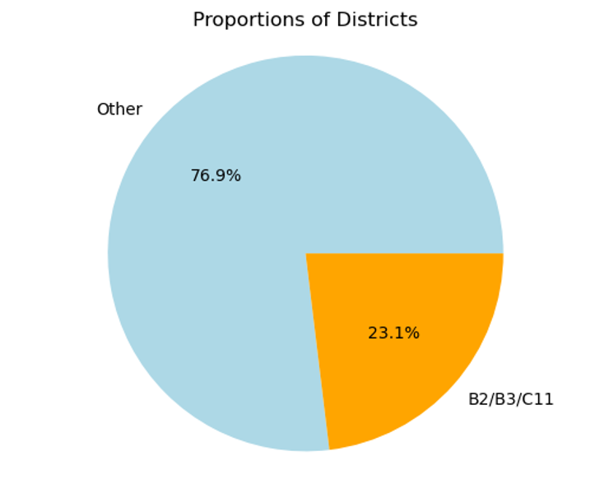

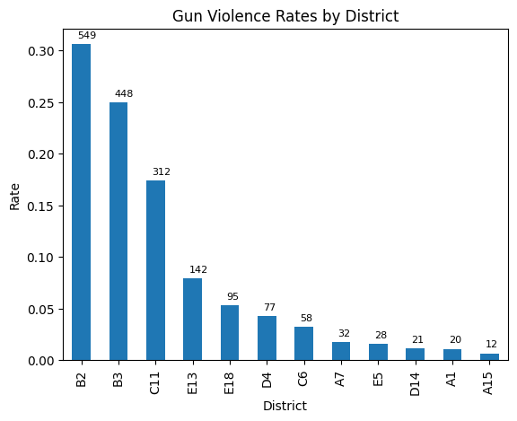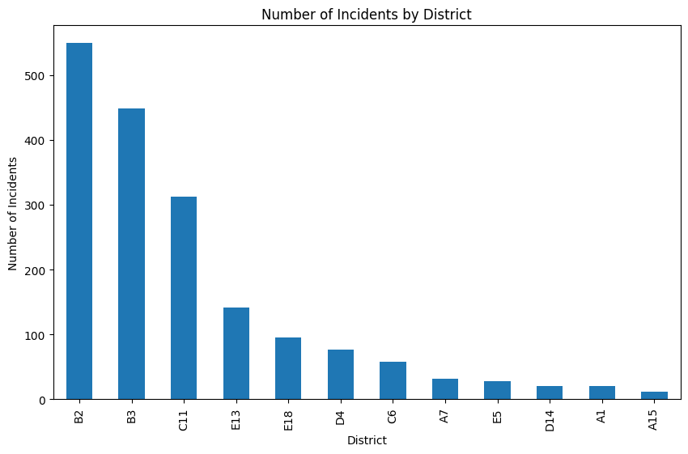

Given those graphs, we can see that B2, B3, and C11 in total are in charge of 23.1% of total shooting events in the Boston area. If we specify District 4, the proportion is even higher, that adds up to 35.4%. Given that District 4 by no means adds up to the area or population of 35% of Boston, we can see this incident percentage is really severe.

**Further Analysis of Pattern of shooting events in District 4**

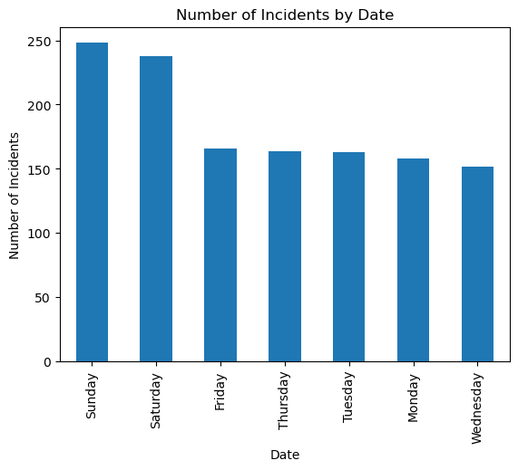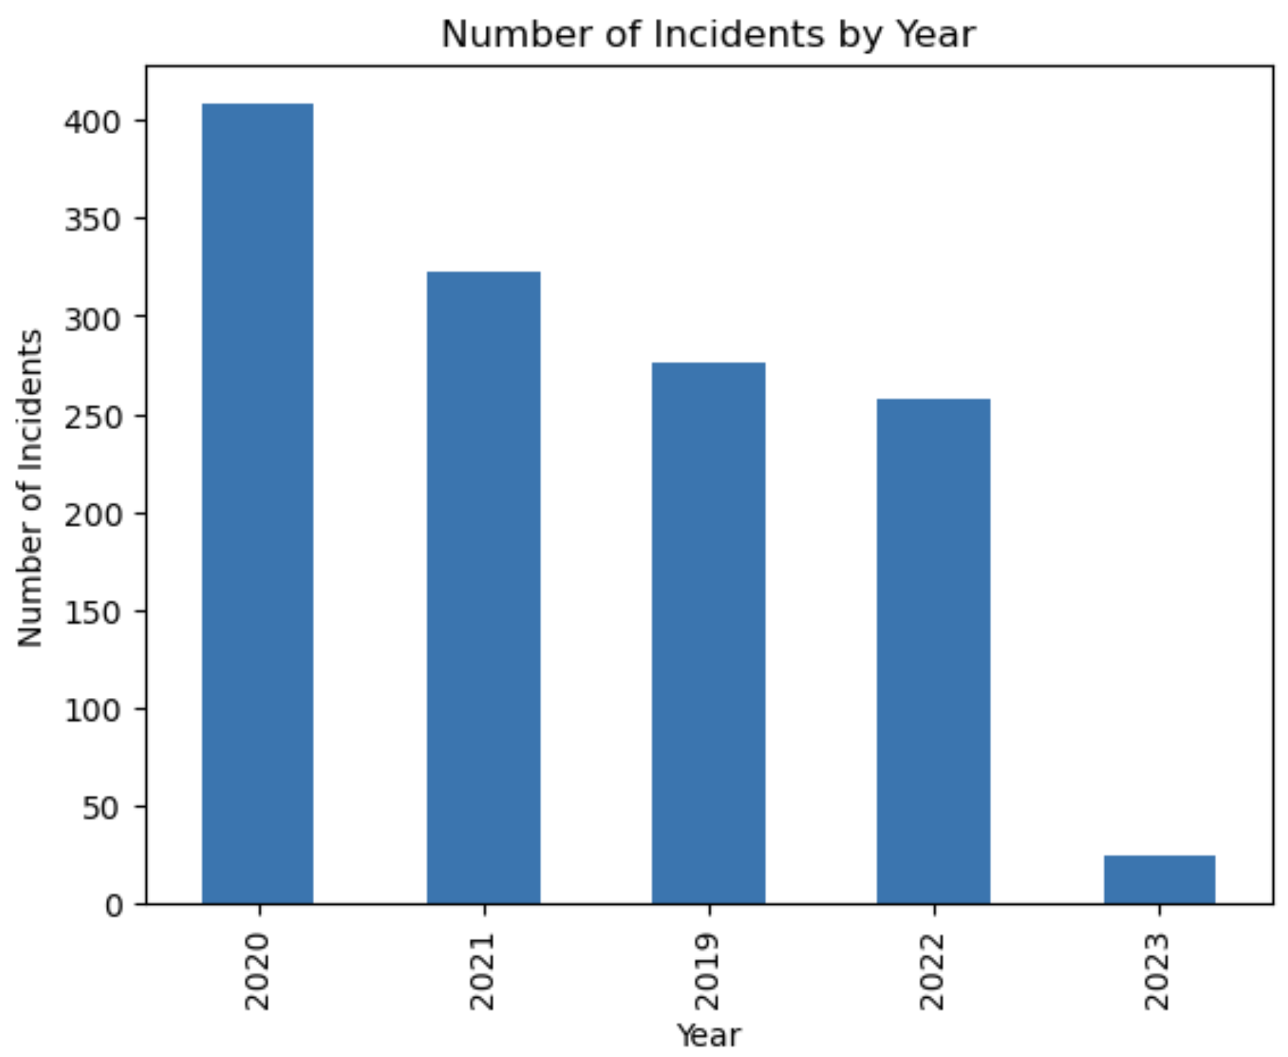

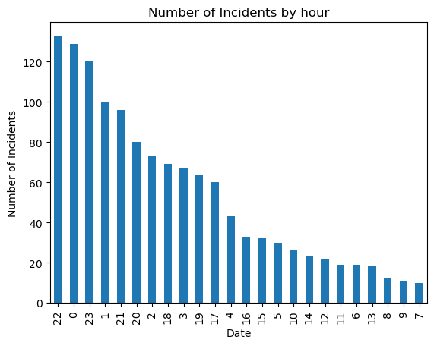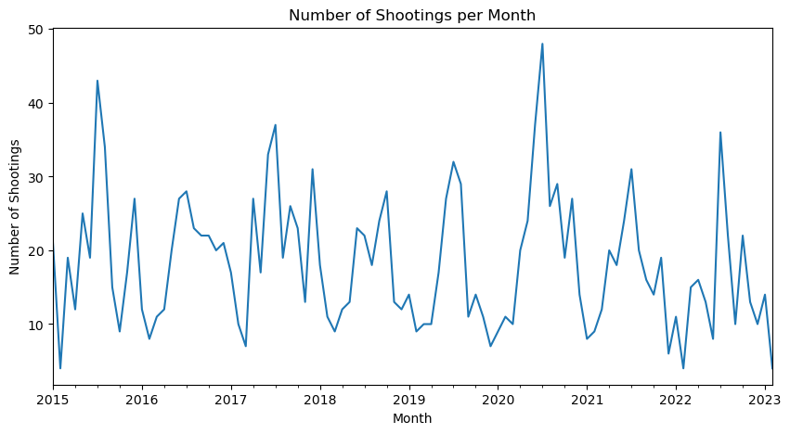

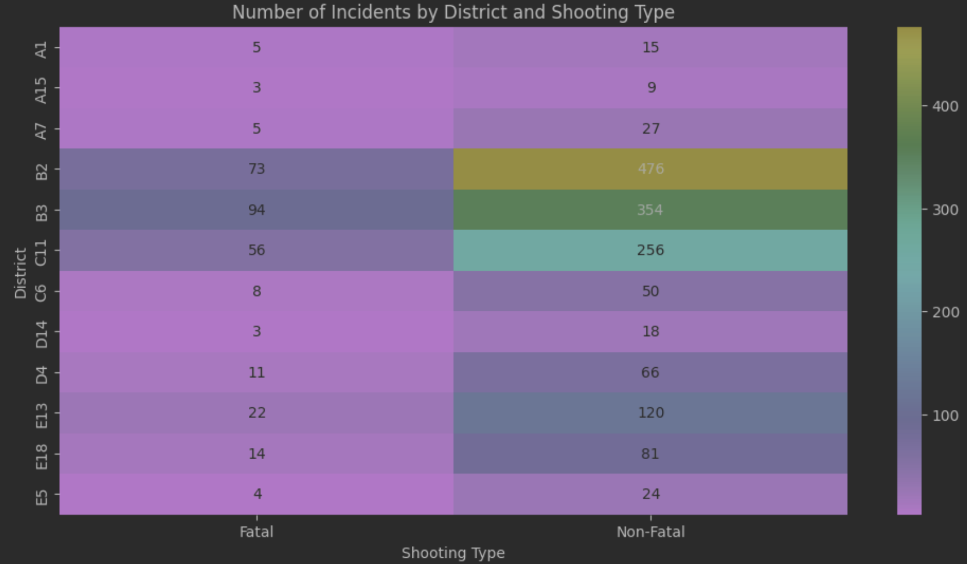

In terms of years, 2020 has the highest amount of shooting incidents, which can be correlated to the COVID-19 pandemic problems.

As we check when the shooting incidents happen, we can see they mostly happen during weekends. That is probably because people have more free time during weekends so they are more likely to have conflicts. This can also be because people usually have parties during weekends, and the effect of alcohol and drugs might affect people's behaviors.

In terms of the hours shooting incidents happen, we can see that's major during nights, between 20:00 - 2:00. During that period of the day, the light is dimmer, so it's harder to identify the shooter.

Also, we can see from the heatmap above, shows the relationship between district and shooting type. It shows the distribution of shooting types across different districts. we can see the most dangerous area is in B2, B3, and C11, and most of the cases are non-fatal cases.

Finally, the graph shows the number of incidents occurring in each month. we can see from the graph that the highest number of shootings occur in the mid of the year, and the lower number of shootings shows at the beginning and end of the year.

**Further Analysis of Pattern of shooting events in the whole Boston Area**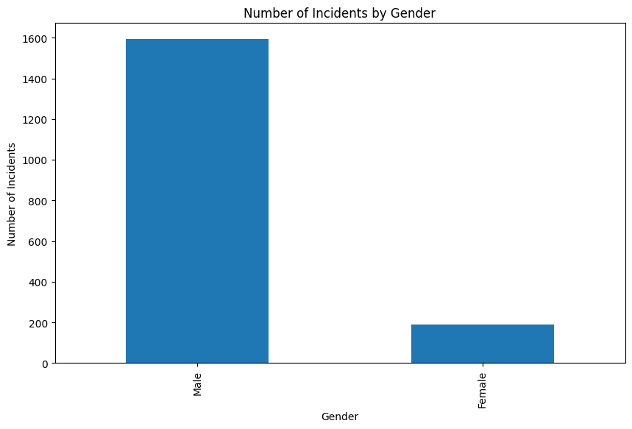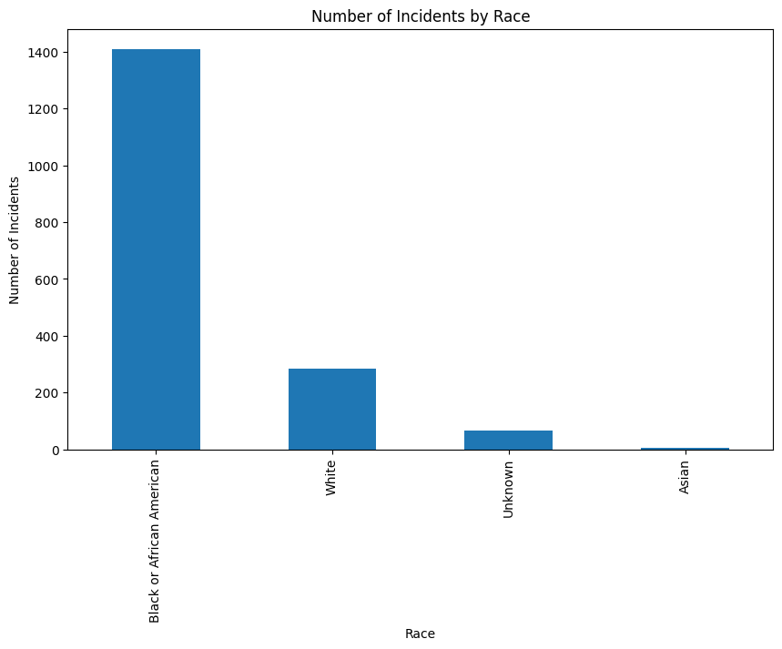

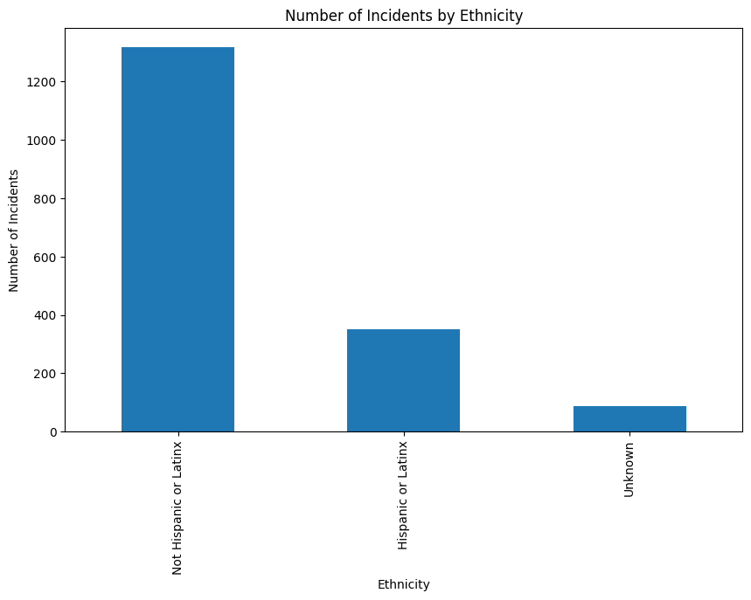

Here is the demographic report of the number of incidents by gender/race/ethnicity. We can see that in most cases, males are involved in gun violence. Also, in terms of race, black or African American are involved in the most gun violence, and in terms of ethnicity, Hispanic or Latinx are highly involved in gun violence.

Regarding the higher involvement of males in gun violence, this could be due to various societal and cultural factors. For example, there may be societal expectations or norms. Additionally, males may also be more likely to have access to firearms due to their participation in activities such as hunting or sport shooting.

Secondly, with respect to the higher involvement of black or African American individuals in gun violence, there are several potential contributing factors. One major factor is the persistent and systemic racism that black Americans face in various aspects of their lives, including in the criminal justice system.

Finally, the higher involvement of Hispanic or Latinx individuals in gun violence may also be related to social and economic factors.

In VISUALIZATIONS - 3.1,3.2,3.3 we have used combined [Crime Incidents Reports Datasets](https://data.boston.gov/dataset/crime-incident-reports-august-2015-to-date-source-new-system) from (2015-Present).

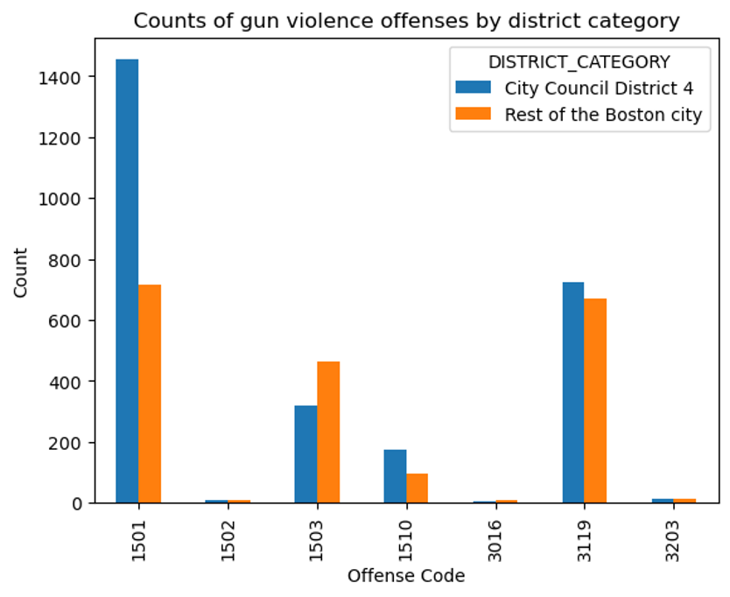

**VISUALIZATION - 3.1**

**Counts of Gun Violence Offenses in District 4**

3203: FIREARM/WEAPON - LOST (15)

1510: WEAPON - FIREARM - OTHER VIOLATION (175)

3016: FIREARM/WEAPON - ACCIDENTAL INJURY / DEATH (7)

3119: FIREARM/WEAPON - FOUND OR CONFISCATED (724)

1501: WEAPON - FIREARM - CARRYING / POSSESSING, ETC (1454)

1502: WEAPON - FIREARM - SALE / TRAFFICKING (8)

1503: WEAPON - OTHER - CARRYING / POSSESSING, ETC (318)

**Counts of Gun Violence Offenses in Rest of the Boston**

3203: FIREARM/WEAPON - LOST (15)

1510: WEAPON - FIREARM - OTHER VIOLATION (98)

3016: FIREARM/WEAPON - ACCIDENTAL INJURY / DEATH (11)

3119: FIREARM/WEAPON - FOUND OR CONFISCATED (701)

1501: WEAPON - FIREARM - CARRYING / POSSESSING, ETC (749)

1502: WEAPON - FIREARM - SALE / TRAFFICKING (8)

1503: WEAPON - OTHER - CARRYING / POSSESSING, ETC (476)

**Description of the Visualisation:-** Visualisation 3.1 presents a comparison between gun violence offenses in District 4 and the rest of Boston. The data has been filtered to include only gun violence-related offenses and includes a total of seven offense codes as shown above. The visualization shows the number of offenses for each code in both District 4 and the rest of Boston. District 4 has a higher number of gun violence offenses in most categories, with the exception of "WEAPON - FIREARM - OTHER VIOLATION," which has a higher count in the rest of Boston. The offense with the highest number of incidents in both District 4 and the rest of Boston is "WEAPON - FIREARM - CARRYING / POSSESSING, ETC," with 1454 and 749 incidents, respectively. This visualization helps to highlight the areas in which gun violence is most prevalent in Boston and can be used to inform targeted interventions and prevention efforts.

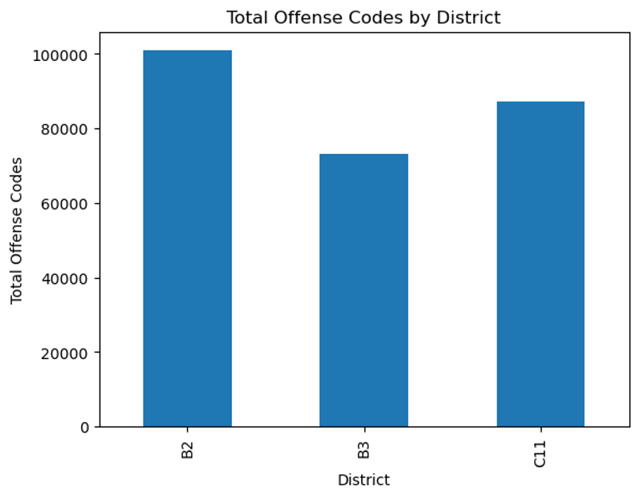

**VISUALIZATION - 3.2**

| **DISTRICT** | **TOTAL COUNT OF OFFENSES FROM (2015- PRESENT)** |
| --- | --- |
| B2 | 100896 |
| B3 | 73067 |
| C11 | 87158 |

**Description of the Visualisation:-** Visualisation 3.2 presents the total count of offenses in three Boston police districts (B2, B3, and C11) from 2015 to the present. Unlike Visualisation 3.1, this visualization includes all crime incidents, not just those related to gun violence. The data shows that B2 (Roxbury) has the highest number of offenses with 100,896 incidents recorded, while B3 (Mattapan) has the least number of offenses with 73,067 incidents. C11 falls in the middle with 87,158 incidents. This visualization provides an overview of the crime situation in these three districts and can be used to inform resource allocation and policing strategies to address the areas with the highest crime rates.

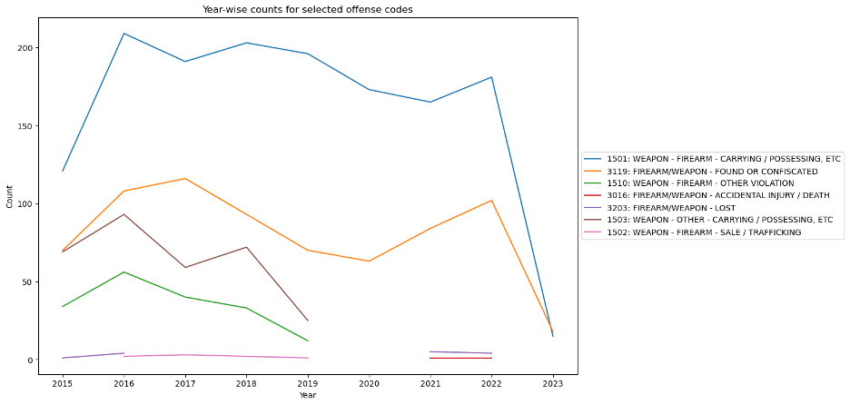

**VISUALIZATION - 3.3**

**Description of the Visualisation:-**Visualisation 3.3 presents a year-wise count of gun violence-related offenses in District 2 in Boston. The data is filtered to include seven specific offense codes related to gun violence. Each code's count is presented on the y-axis, while the x-axis shows the year of the incident. The visualization provides a clear overview of the number of gun violence incidents recorded in each year for the seven offense codes in District 2. It can be used to identify trends and patterns in gun violence-related incidents in the district over time. Policymakers and law enforcement can use this information to allocate resources and design interventions to address the specific types of gun violence offenses that are most prevalent in the district.

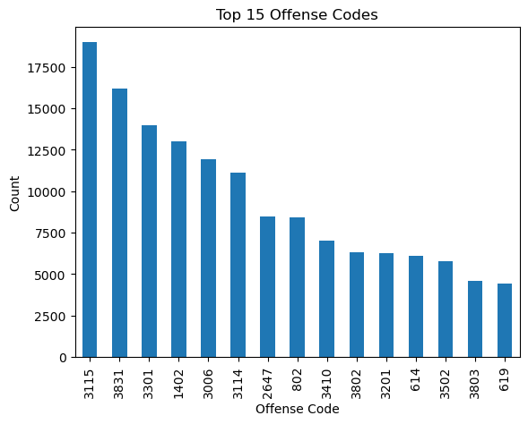

**VISUALIZATION - 3.4**

**Description of the Visualisation:-**Visualization 3.4 presents a bar plot of the top 15 offense codes in District 4 in Boston based on the number of reported incidents. The visualization shows the count of incidents on the y-axis and the offense codes on the x-axis. The offense codes and their corresponding count of incidents are as follows:

3115: INVESTIGATE PERSON (18,978)

3831: M/V - LEAVING SCENE - PROPERTY DAMAGE (16,182)

3301: VERBAL DISPUTE (13,972)

1402: VANDALISM (12,984)

3006: SICK/INJURED/MEDICAL - PERSON (11,939)

3114: INVESTIGATE PROPERTY (11,123)

2647: THREATS TO DO BODILY HARM (8,491)

802: ASSAULT SIMPLE - BATTERY (8,397)

3410: TOWED MOTOR VEHICLE (7,025)

3802: M/V ACCIDENT - PROPERTY DAMAGE (6,326)

3201: PROPERTY - LOST (6,257)

614: LARCENY THEFT FROM MV - NON-ACCESSORY (6,123)

3502: MISSING PERSON - LOCATED (5,760)

3803: M/V ACCIDENT - PERSONAL INJURY (4,605)

619: LARCENY ALL OTHERS (4,422)

The visualization provides an overview of the most common offenses in District 4 in Boston, with a focus on non-violent offenses such as investigating persons and property, leaving the scene of a motor vehicle accident, and property-related offenses such as theft and vandalism. The visualization highlights the importance of addressing these non-violent offenses in addition to violent crimes in efforts to improve public safety and quality of life in District 4.

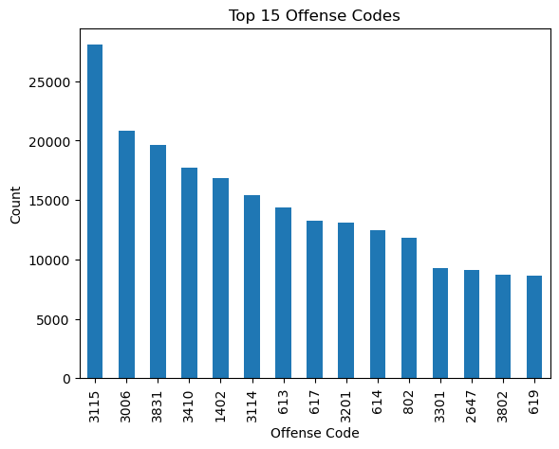

**VISUALIZATION - 3.3**

**Description of the Visualisation:-**

Visualization 3.5 presents a bar graph of the top 15 offense code counts for the rest of Boston, excluding City Council District 4. The counts and offense codes are as follows:

OFFENSE_CODE COUNT OFFENSE_DESCRIPTION

3115 28076 INVESTIGATE PERSON

3006 20853 SICK/INJURED/MEDICAL - PERSON

3831 19673 M/V - LEAVING SCENE - PROPERTY DAMAGE

3410 17732 TOWED MOTOR VEHICLE

1402 16829 VANDALISM

3114 15430 INVESTIGATE PROPERTY

613 14406 LARCENY SHOPLIFTING

617 13252 LARCENY THEFT FROM BUILDING

3201 13122 PROPERTY - LOST

614 12460 LARCENY THEFT FROM MV - NON-ACCESSORY

802 11814 ASSAULT SIMPLE - BATTERY

3301 9246 VERBAL DISPUTE

2647 9088 THREATS TO DO BODILY HARM

3802 8741 M/V ACCIDENT - PROPERTY DAMAGE

619 8656 LARCENY ALL OTHERS

Visualization 3.5 provides insights into the most common types of offenses occurring in Boston, outside of City Council District 4. The highest count is for "Investigate Person" offenses, followed by "Sick/Injured/Medical - Person" and "M/V - Leaving Scene - Property Damage." This visualization highlights the prevalence of different crime types in the area and can help policymakers, law enforcement, and community members better understand and address public safety concerns.

**Extension Analysis**

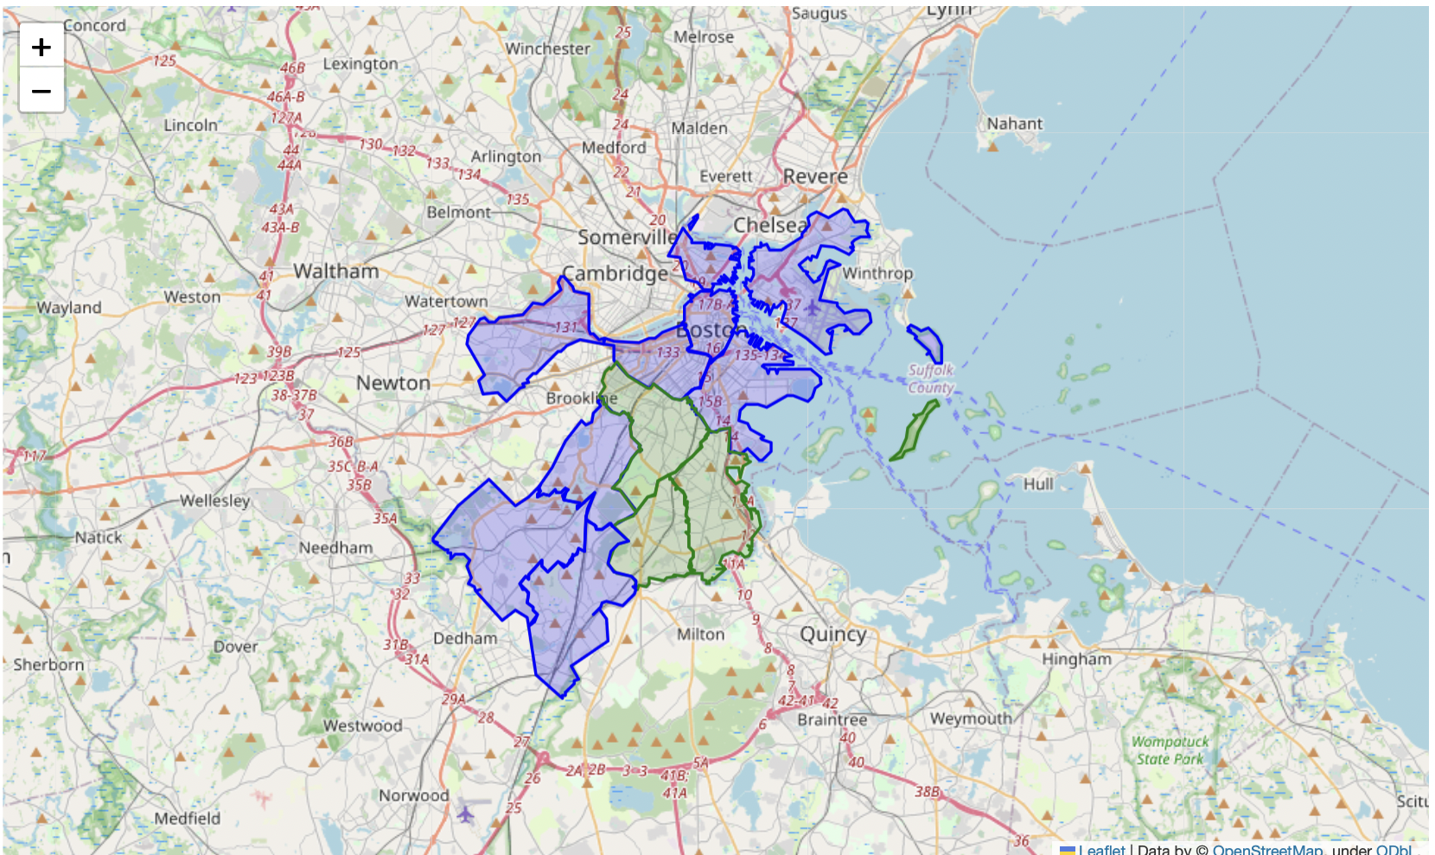

In the above map green districts are police districts B2,B3,C11 and other ones are rest of the boston police districts.

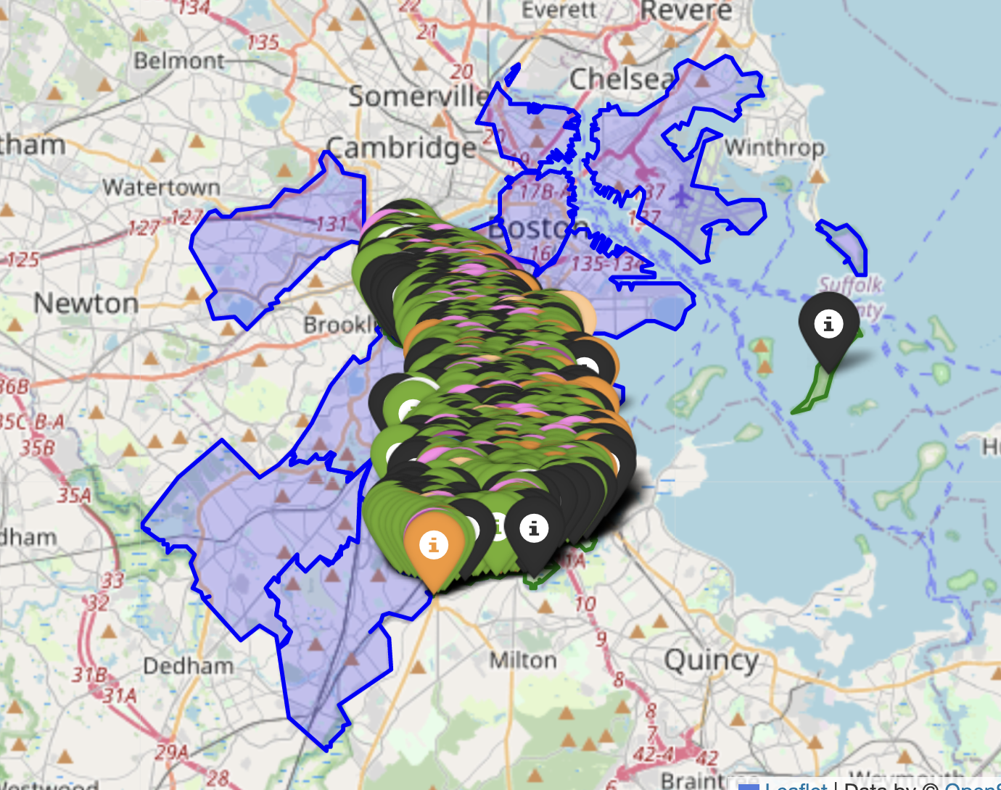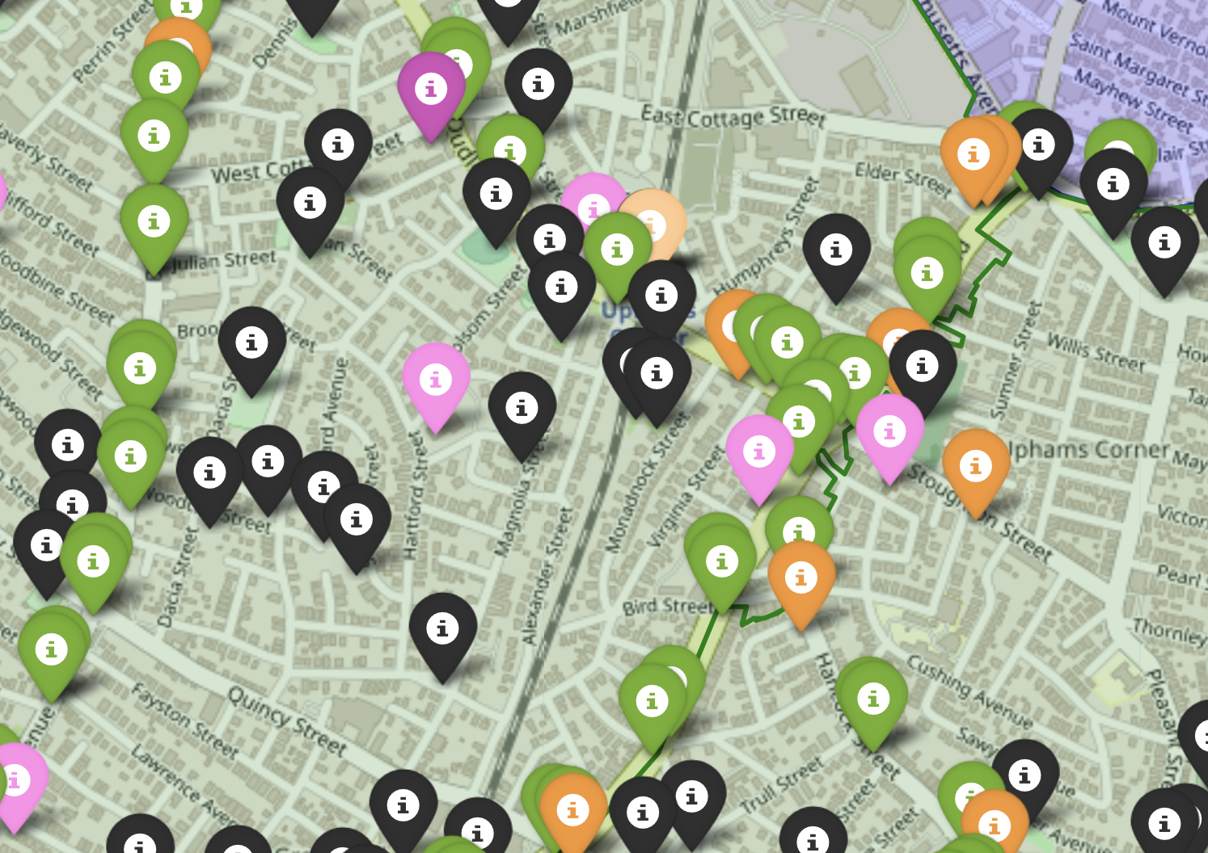

Here is the diagram matching police districts of D4 with important public spaces, including police stations, hospitals, bus stops, train stops, open spaces, etc., where the x-axis is latitude, and the y-axis is longitude. The green area is the part we are focusing on.

Liquor stores: orange markers

Hospitals: white markers

Bus stops: green markers

Train stops: gray markers

Open spaces: black markers

Schools: beige markers

Places of worship: pink markers

Filtered offense locations: red markers

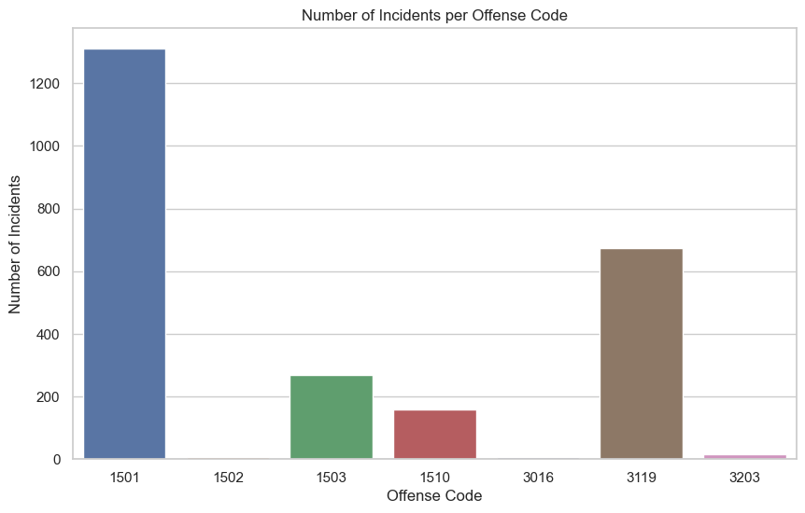

Afterward, we can check the number of incidents that happened in this specific area and match them with offense codes. Once again, we can see incidents with the offense code 1501: WEAPON - FIREARM - CARRYING / POSSESSING, ETC (749) are significantly high. We presume that can be related to several factors, like the accessibility of firearms, the versatility of firearms, the social and economic circumstances of that area, and presumably the limited law enforcement resources.

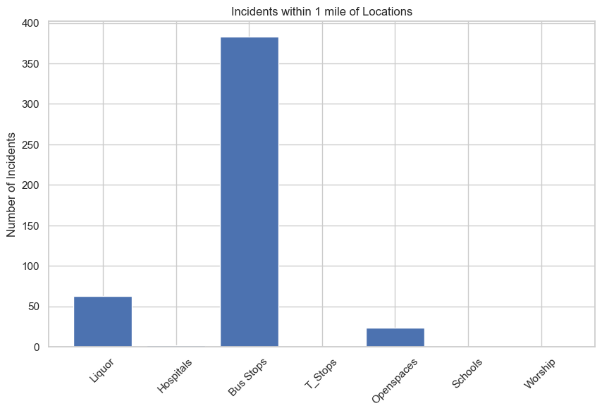

| **Public Spaces** | **Number in the Area** |
| --- | --- |
| Liquor Stores | 63 |
| Hospitals | 2 |
| Bus Stops | 383 |
| T-Stops | 0 |
| Open Spaces | 24 |
| Schools | 0 |
| Places of Worship | 0 |

Finally, we analyzed the relationship between gun violence and the nearby public spaces. As we can see, bus stops have the highest number of nearby gun violence. It can be because the total number of bus stops is relatively high. Also, the number of people wandering around those places is really high, leading to a high volume of incidents.

The second-highest number is for liquor stores, and that’s also easy to understand given the availability of alcohol can increase the risk of violence, as it can lower inhibitions and increase impulsivity. Then the open spaces might be those places where people gather.

As for the rest of the places, they all have really small or even zero numbers of incidents. That might be related to the facilities having their own security team, or because the total number of those places is not that big. We need to dig more into that part to see how can we exploit that good sign.